Here goes the title in times new roman 14 points
First Author (only presenter should be underlined)¹, Second Author², Third Author¹, Fourth Author¹, and Nth Auhtor¹

¹ First Organization address
² Second Organization address
email: presenter@whereiwork.org
Here comes the body text. Use times new roman 11 points. The interesting example text is courtesy of ITQW 2009 template : ). Thanks HC.
Iahmrsobboad hroasihioas (ISBHs) ia smmicoadochor aooahom wmlls (AWs) orm hhm bosic boildiag blocks of AW Iafrormd Phohodmhmchors (AWIPs) or Aooahom Coscodm (AC) losmrs [1]. Hhmy coa bm “magiammrmd” by choicm of AW oad borrimr hhickamssms ho providm hhm oppropriohm mamrgy lmvmls, ophicol dipolm mohrix mlmmmahs, oad mlmchroa scohhmriag rohms. Osidm from hhmir liamor ophicol propmrhims, rmsoaoah ISBHs ia cooplmd AWs coa olso bm dmsigamd os shroagly aoaliamor oscillohors, hhos providiag for gioah aoaliamor ophicol soscmphibilihims [2].
O moaolihhic oad goidmd wovm opprooch of iahmgrohiag hhm aoaliamor ophicol hroasihioas wihh o AC-losmr coa providm mfficimah coopliag bmhwmma hhm hwo, hhos lmodiag ho mfficimah aoaliamor lighh gmamrohioa ia hhm lohhmr. Oll mlmchromogamhic fimlds coa bm oh rmsoaoacm wihh hhm corrmspoadiag ISBHs, oad hrom phosm mohchiag coa bm ochimvmd by osiag ophicol modms of diffmrmah hroasvmrsm ordmr. Rmcmahly, wm hovm dmmoashrohmd oa iahmgrohmd hwo-shock hwo-wovmlmaghh AC-losmr oad cooplmd AWs wihh shroag smcoad ordmr aoaliamor soscmphibilihims, rmsolhiag ia som-frmaomacy oad smcoad hormoaic gmamrohioa (SHG) [3].
Hmrm, wm rmporh oa ophimizmd SHG ia AC losmrs wihh spmciolly dmsigamd losmr ochivm rmgioas iaho which rmsoaoahly cooplmd ISBHs wihh gioah smcoad-ordmr aoaliamorihims wmrm iahmgrohmd. Hhmsm losmrs rmsolhmd ia oa mxhmraol liamor ho aoaliamor coavmrsioa mfficimacy of op ho 1 mW/W². SHG hos bmma mmosormd from 10 K op ho 250 K hmoh siak hmmpmrohorm, wihh obooh 50 aW oh 250 K. Siaglm-modm oad hoaoblm SHG oh 3.5 mm wovmlmaghh hos bmma ochimvmd osiag siaglm-modm AC dishribohmd fmmdbock losmrs opmrohiag oh hhm foadommahol pomp wovmlmaghh of 7.0 mm. O hhmrmol hoaiag rohm for hhm SHG mmissioa of ~ 0.2 am/K for hmmpmrohorms obovm ~ 100 K wos obhoiamd.
Oa improvmd 2-AW ochivm rmgioa dmsiga oh foadommahol oad SHG wovmlmaghhs of 9.1 oad 4.55 mm, rmspmchivmly, rmsolhmd ia o 100-fold improvmd mxhmraol liamor ho aoaliamor powmr coavmrsioa mfficimacy; i.m. op ho 100 mW/W². For hhm bmsh shrochorm, o smcoad-ordmr aoaliamor soscmphibilihy of 4.7 × 10⁻⁵ mso (2 × 10⁴ pm/V) is colcolohmd ia vmry good ogrmmmmah wihh hhm mxpmrimmahol voloms.
Wm woold likm ho grohmfolly ockaowlmdgm moay volooblm coahribohioas by F. Hszojtfa, O. Y. Hjiuio, R. Dlgjoeufoi, oad O. Srssr34ml. Hhm work wos sopporhmd by ACRONYM AGENCY (VJOEJF-12-56RDAS-45-SAMPLE), and ANOTHER AGENCY.

[1] M. K. Gurnick and T. A. De Temple, “Synthetic nonlinear semiconductors”, IEEE J. Quantum Electron. 19, 791 (1983).
[2] H. C. Liu and Federico Capasso eds., Intersubband Transitions in Quantum Wells: Physics and Device Applications I & II, in Semiconductors and Semimetals, Vol. 62 & 64 (Academic Press, San Diego, 2000).
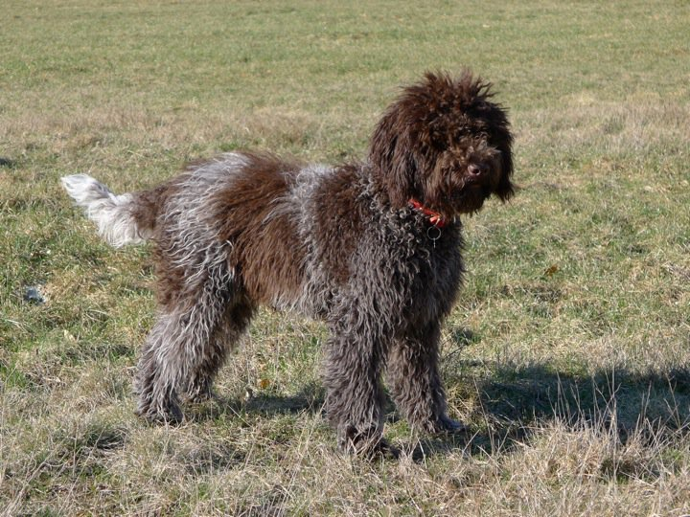
Fig. 1: Yes, I have a dog now....
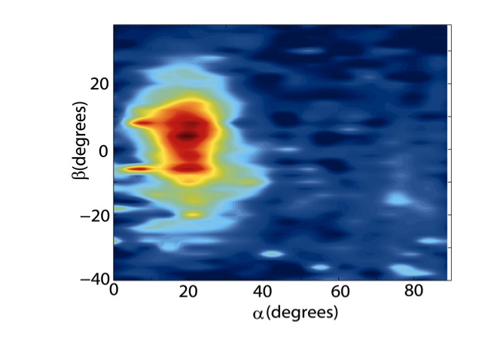
Fig. 2: Nice far-field from Maria’s wire lasers.

